##### A

##### Industrial-Oriented Mini Project On

**E-VOTING SYSTEM USING ETHEREUM BLOCKCHAIN**

(Submitted in partial fulfilment of the requirements for the award of Degree)

**BACHELOR OF TECHNOLOGY**

##### In

**COMPUTER SCIENCE AND ENGINEERING**

##### By

##### B.Bhargavi (227R1A0572) B.Bharath Raj (227R1A0573)

##### B.Saicharan (227R1A0568)

##### Under the Guidance of

#### Dr. ASHUTOSH SAXENA

(Dean of R&D)



**DEPARTMENT OF COMPUTER SCIENCE AND ENGINEERING**

**CMR TECHNICAL CAMPUS**

###### UGC AUTONOMOUS

(Accredited by NAAC, NBA, Permanently Affiliated to JNTUH, Approved by AICTE, New Delhi)

Recognized Under Section 2(f) & 12(B) of the UGCAct.1956, Kandlakoya (V), Medchal Road, Hyderabad-501401.

**Iune, 2025.**

**DEPARTMENT OF COMPUTER SCIENCE AND ENGINEERING**



**CERTIFICATE**

This is to certify that the project entitled “**E-VOTING SYSTEM USING ETHEREUM BLOCKCHAIN**” being submitted by **B.Bhargavi (227R1A0572), B.Bharath Raj (227R1A0573) & B.Saicharan (227R1A0568)** in partial fulfilment of the requirements for the award of the degree of B.Tech in Computer Science and Engineering to the Jawaharlal Nehru Technological University Hyderabad, during the year 2024-25.

The results embodied in this thesis have not been submitted to any other University or Institute for the award of any degree or diploma.

Dr.Ashutosh Saxena Dr. Nuthanakanti Bhaskar Dean of R&D HoD

INTERNAL GUIDE

Dr. A. Raji Reddy Signature of External Examiner DIRECTOR

Submitted for viva voice Examination held on

**ACKNOWLEDGEMENT**

We take this opportunity to express our gratitude to the people who have been instrumental in the successful completion of this project, we take this opportunity to express our profound gratitude and deep regard to our guide **Dr.Ashutosh Saxena,Dean of R&D** for his exemplary guidance, monitoring and constant encouragement throughout the project work. The blessing, help and guidance given by him shall carry us a long way in the journey of life on which we are about to embark.

We take this opportunity to extend our heartfelt appreciation to the Project Review Committee (PRC) Coordinators—**Y.Varalakshmi,B.Sekhar,D.Nageswar Rao,SVSV Prasad Sanaboina**—for their unwavering support, insightful guidance, and valuable inputs, which played a crucial role in steering this project through its various stages.

Our sincere appreciation also goes to **Dr. Nuthanakanti Bhaskar**, Head, for his encouragement and continuous support in ensuring the successful completion of our project.

We are deeply grateful to **Dr. A. Raji Reddy**, Director, for his cooperation throughout the course of this project. Additionally, we extend our profound gratitude to Sri. **Ch. Gopal Reddy**, Chairman, Smt. **C. Vasantha Latha**, Secretary and Sri. **C. Abhinav Reddy**, Vice-Chairman, for fostering an excellent infrastructure and a conducive learning environment that greatly contributed to our progress.

We also acknowledge and appreciate the guidance and assistance provided by the faculty and staff of **CMR Technical Campus**, whose contributions have been invaluable in bringing this project to fruition.

Lastly, we sincerely thank our families for their unwavering support and encouragement. We also extend our gratitude to the teaching and non-teaching staff of CMR Technical Campus for their guidance and assistance. Their contributions, along with the support of everyone who helped directly or indirectly, have been invaluable in the successful completion of this project.

B.Bhargavi (227R1A0572)

B.Bharath Raj (227R1A0573)

B.Saicharan (227R1A0568)

**VISION AND MISSION**

**INSTITUTE VISION:**

##### To Impart quality education in serene atmosphere thus strive for excellence in Technology and Research.

**INSTITUTE MISSION:**

##### To create state of art facilities for effective Teaching- Learning Process.

##### Pursue and Disseminate Knowledge based research to meet the needs of Industry & Society.

##### Infuse Professional, Ethical and Societal values among Learning Community.

**DEPARTMENT VISION:**

##### To provide quality education and a conducive learning environment in computer engineering that foster critical thinking, creativity, and practical problem-solving skills.

**DEPARTMENT MISSION:**

##### To educate the students in fundamental principles of computing and induce the skills needed to solve practical problems.

##### To provide State-of-the-art computing laboratory facilities to promote industry institute interaction to enhance student’s practical knowledge.

##### To inculcate self-learning abilities, team spirit, and professional ethics among the students to serve society.

**ABSTRACT**

This project is titled as “E-VOTING SYSTEM USING ETHEREUM BLOCKCHAIN”. Electronic voting (e-voting) has emerged as a promising alternative to traditional paper-based voting methods. However, existing e-voting systems often suffer from issues such as lack of transparency, vulnerability to hacking, and the need for centralized control, which can lead to concerns about the integrity and legitimacy of election outcomes. To overcome these limitations, this paper proposes an e-voting system built on the Ethereum blockchain, aiming to enhance security, transparency, and trust in the electoral process.The proposed system utilizes Ethereum's smart contract functionality to automate the voting process, allowing votes to be cast, recorded, and counted in a decentralized manner. Smart contracts act as tamper-proof executors of election logic, ensuring that all transactions are transparent and irreversible once added to the blockchain. This eliminates the need for a central authority and reduces the risk of fraud and manipulation.To ensure voter privacy and authentication, the system incorporates cryptographic techniques such as public-key encryption and digital signatures. Each voter is uniquely identified and allowed to cast a single vote, which is anonymized before being recorded on the blockchain. This mechanism upholds the principle of voter confidentiality while preventing double voting and unauthorized access.By storing voting data on the Ethereum blockchain, the system provides a transparent and verifiable ledger of all electoral activities. Stakeholders, including voters and election officials, can independently verify results without compromising voter privacy. Furthermore, the decentralized architecture enhances the system’s resilience against denial-of-service attacks and other cyber threats.

**LIST OF FIGURES**

**FIGURE NO FIGURE NAME PAGE NO**

Figure 3.1 Project Architecture of E-voting 15

System using Ethereum Blockchain

Figure 3.2.1 Class Diagram for E-voting system 19

Using Ethereum Blockchain

Figure 3.2.2 Use Case Diagram for Admin 20

Figure 3.2.3 Use Case Diagram for User 20

Figure 3.2.4 Sequence Diagram for Admin 21

Figure 3.2.5 Sequence Diagram for Admin 21

Figure 3.2.6 Activity Diagram for Admin 22

Figure 3.2.7 Activity Diagram for User 22

Figure 3.3.1 Dataflow Diagram for Admin 23

Figure 3.3.2 Dataflow Diagram for User 24

Figure 5.1 GUI/Main interface of E-voting System 32

using Ethereum Blockchain

Figure 5.2 Admin Login Screen of E-voting System 33

using Ethereum Blockchain

Figure 5.3 Admin can click on Add Party Detail link 33

to add Party Details of E-voting

System using Ethereum Blockchain

Figure 5.4 Adding Party of E-voting System using 34

Ethereum Blockchain

Figure 5.5 View Party Details of E-voting System 34

Using Ethereum Blockchain

Figure 5.6 Displaying added party details and now 35

click on Logout lint to logout as admin

and then add new user

Figure 5.7 Adding new user and then selecting face 35

photo taken from webcam

Figure 5.8 New user signup process completed and 36

now login as this user to cast vote

Figure 5.9 User Login screen of E-voting system 37

using Ethereum Blockchain

Figure 5.10 Cast user vote of E-voting system using 37

Ethereum Blockchain

Figure 5.11 Webcam is running and then by showing 38

person face we need to click onTake

Snapshot

Figure 5.12 person face is capture and validate user to 38

click on button validate user

Figure 5.13 Displaying list of candidates and now user 39

click on click here option to cast vote

Figure 5.14 Hash code validation of user in E-voting 39

system using Ethereum Blockchain

Figure 5.15 Same user trying again to cast there vote of 40

E-voting system using Ethereum Blockchain

Figure 5.16 Admin login screen of E-voting system 40

using Ethereum Blockchain

Figure 5.17 Admin can viewing the votes of E-voting 41

system using Ethereum Blockchain

Figure 5.18 Vote Counting of E-voting system 41

using Ethereum blockchain

|  |  |  |
| --- | --- | --- |
|  | **LIST OF TABLES** |  |
| **TABLE NO** | **TABLE NAME** | **PAGE NO** |
| Table 6.2.1 | Test Cases | 43 |
|  |  |  |

**TABLE OF CONTENTS**

|  |  |
| --- | --- |
| **ABSTRACT** | i |
| **LIST OF FIGURES** | ii |
| **LIST OF TABLES** | v |
| **1. INTRODUCTION** | 1 |
| 1.1 PROJECT PURPOSE | 1 |
| 1.2 PROJECT FEATURES | 2 |
| **2. LITERATURE SURVEY** | 4 |
| 2.1 REVIEW OF RELATED WORK | 6 |
| 2.2 DEFINITION OF PROBLEM STATEMENT | 8 |
| 2.3 EXISTING SYSTEM | 9 |
| 2.4 PROPOSED SYSTEM | 11 |
| 2.5 OBJECTIVES | 13 |
| 2.6 HARDWARE & SOFTWARE REQUIREMENTS | 14 |
| 2.6.1 HARDWARE REQUIREMENTS | 14 |
| 2.6.2 SOFTWARE REQUIREMENTS | 14 |

3.

|  |  |  |
| --- | --- | --- |
| **SYSTEM** | **ARCHITECTURE & DESIGN** | 15 |
| 3.1 | PROJECT ARCHITECTURE | 15 |
| 3.2 | DESCRIPTION | 16 |
| 3.3 | DATA FLOW DIAGRAM | 23 |

1. IMPLEMENTATION 24
   1. ALGORITHMS USED 24
   2. SAMPLE CODE 28
2. RESULTS & DISCUSSION 32
3. VALIDATION 42
   1. INTRODUCTION 42
   2. TEST CASES 43
4. CONCLUSION & FUTURE ASPECTS 44
   1. PROJECT CONCLUSION 44
   2. FUTURE ASPECTS 45
5. BIBLIOGRAPHY 46
   1. REFERENCES 46
   2. GITHUB LINK 47
6. **INTRODUCTION**
   1. **INTRODUCTION**

The project, titled "E-Voting system using Ethereum blockchain," Elections are fundamental to democratic societies, serving as the primary means through which citizens express their will and participate in governance. As technology continues to evolve, there is a growing interest in adopting electronic voting (e-voting) systems to improve the efficiency, accessibility, and scalability of elections. However, conventional e-voting systems are often centralized and vulnerable to a range of threats, including cyberattacks, data manipulation, system failures, and lack of transparency. These limitations can undermine public trust in the electoral process and raise serious concerns about the security and legitimacy of election outcomes.

Blockchain technology, particularly the Ethereum platform, offers a promising solution to these challenges. Blockchain is a decentralized, distributed ledger system that provides transparency, immutability, and security by design. Ethereum extends the capabilities of blockchain by supporting smart contracts — self-executing programs that run on the blockchain and enforce predefined rules automatically. These features make Ethereum an ideal platform for developing secure and transparent e-voting systems.

This paper proposes an e-voting system built on the Ethereum blockchain to enhance the integrity, trust, and transparency of elections. In this system, voter identities are authenticated securely, and votes are cast through smart contracts that ensure each vote is recorded accurately and cannot be altered or deleted. The decentralized nature of the blockchain removes the reliance on a central authority, thereby reducing the risk of fraud, manipulation, and single points of failure.

**1.1 PROJECT PURPOSE**

The primary purpose of this project is to develop a decentralized e-voting system using the Ethereum blockchain that addresses the key challenges faced by traditional and electronic voting systems.

Existing voting systems often depend on centralized infrastructures, which can be vulnerable to security breaches, vote manipulation, and lack of transparency. These weaknesses can lead to a loss of public confidence in the integrity of elections. This project aims to provide a secure, transparent, and tamper-proof alternative by harnessing the features of blockchain technology.

By utilizing Ethereum's smart contracts, the proposed system ensures that every vote is recorded immutably and cannot be altered or deleted after submission. This eliminates the possibility of vote tampering or double voting. Smart contracts also automate the voting process, making it more efficient and eliminating the need for manual vote counting or third-party verification. Each step of the process—from voter registration and authentication to vote casting and result tallying—is securely managed on the blockchain.

Another major goal of this project is to enhance transparency and verifiability in elections. All voting transactions are recorded on a public, decentralized ledger that can be audited in real time, ensuring that the entire election process is open to scrutiny while still protecting the anonymity of voters. Cryptographic techniques are employed to maintain voter privacy while ensuring that each eligible voter casts only one vote.

**1.1 PROJECT FEATURES**

The e-voting system developed using the Ethereum blockchain introduces a range of features aimed at enhancing the security, transparency, and efficiency of the electoral process. One of the core features of the system is **decentralization**, which eliminates the need for a central authority or intermediary. By distributing control across the Ethereum blockchain, the system reduces the risk of manipulation, fraud, or a single point of failure.Another key feature is the use of **smart contracts** to automate the election process. Smart contracts are self-executing programs that enforce rules and logic defined for the election, such as registering voters, allowing one vote per user, and counting votes automatically. Once deployed on the blockchain, these contracts cannot be altered, ensuring that the election process remains tamper-proof and fully auditable.

The system also includes voter authentication using unique digital identities or cryptographic keys. This ensures that only eligible voters can participate while maintaining voter privacy through the use of anonymization techniques. Each vote is securely linked to an authenticated identity without revealing personal information, preserving the integrity of the election without compromising confidentiality.Transparency and auditability are central to the system’s design. Every transaction, including votes cast, is recorded on the Ethereum blockchain and can be verified publicly. This makes the entire voting process traceable and trustable by all participants, including voters, election officials, and observers. Additionally, real-time vote tallying allows for instant updates on election progress, reducing the time and needed to count and validate results manually.

**2.LITERATURE SURVEY**

**2.LITERATURE SURVEY**

**[1] N. Kshetri and J. Voas, “Blockchain-Enabled E-Voting,” IEEE Software, vol. 35, pp. 95-99, July 2018.**

This paper explores how blockchain technology can enhance the transparency, trust, and security of electronic voting systems. Kshetri and Voas discuss both the potential and limitations of implementing blockchain in e-voting, such as immutable recordkeeping and challenges in voter anonymity. The article serves as a conceptual foundation for understanding how blockchain could transform electoral systems.

[**2] M. Pawlak, J. Guziur, and A. Poniszewska-Maranda**, “Voting Process with Blockchain Technology: Auditable Blockchain Voting System,” in Lecture Notes on Data Engineering and Communications Technologies, pp. 233-244, Springer, Cham, 2019.

This publication provides a more technical and practical approach to blockchain-based voting. The authors propose an auditable system where votes are transparently recorded on a blockchain, ensuring integrity and reducing possibilities for tampering. Their model emphasizes end-to-end verifiability and privacy, making it a valuable reference for system design.

**[3] B. Singhal, G. Dhameja, and P. S. Panda, “How Blockchain Works,” in Beginning Blockchain, pp. 31-148, Apress, 2018**.

This book chapter offers a comprehensive explanation of blockchain technology, including consensus mechanisms, smart contracts, and decentralized applications. It's essential for understanding the technical backbone of any blockchain voting system. The concepts explained here are foundational to building secure and efficient e-voting applications.

**[4] Agora, “Agora Whitepaper,” 2018.**

Agora’s whitepaper introduces a real-world application of blockchain in voting, proposing a system that emphasizes transparency, security, and verifiability. The

document outlines how Agora’s platform operates, particularly how votes are encrypted and stored on a blockchain, thus enabling real-time auditing and vote verification.

**[5] R. Perper, “Sierra Leone is the first country to use blockchain during an election - Business Insider,” 2018.**

This article discusses a significant milestone where Sierra Leone became the first nation to trial blockchain in a national election. Though blockchain was used to verify votes rather than cast them, it marked an important real-world test of the technology's potential in the democratic process, sparking global interest and debate.

[**6] S. Nakamoto, “Bitcoin: A Peer-to-Peer Electronic Cash System,” tech. rep., 2008.**

Nakamoto’s whitepaper laid the foundation for modern blockchain technology. While it focuses on digital currency, the principles of decentralization, cryptographic verification, and distributed consensus described are directly applicable to secure e-voting systems, forming the basis for trustless, tamper-proof voting mechanisms.

**[7] G. Wood et al., “Ethereum: A secure decentralized generalized transaction ledger,” Ethereum project yellow paper, vol. 151, pp. 1-32, 2014.**

Ethereum introduced smart contracts, which are pivotal in automating and securing e-voting processes. This paper explains the underlying protocol and architecture of Ethereum, showing how developers can build custom decentralized applications (dApps) for voting, identity verification, and ballot tracking.

**[8] S. Landers, “Netvote: A Decentralized Voting Platform – Netvote Project Medium,” 2018.**

Netvote is a blockchain-based voting solution focused on usability and decentralized governance. This article outlines how Netvote ensures that election results are tamper-proof, verifiable, and accessible. It showcases an example of a working system that combines blockchain with practical voting needs, including anonymity and auditability.

**2.1 REVIEW OF RELATED WORK**

The development of secure and transparent electronic voting systems has been a growing area of research, driven by the need for trustworthy and efficient electoral processes. Researchers have explored a wide range of techniques, from conventional digital voting frameworks to blockchain-based decentralized models. This review summarizes key approaches, their methodologies, and the progression toward the integration.

**1. Traditional Electronic Voting Systems**

Early electronic voting systems primarily focused on digitizing the ballot process through centralized platforms. These systems often relied on secure servers, databases, and encrypted communications to ensure data integrity and voter privacy. Although these systems improved the speed and convenience of voting, they were prone to single points of failure, cyberattacks, and lack of transparency. Voter trust remained a significant challenge due to the centralized nature of control, limited auditability, and potential for manipulation of results.

**2. Cryptographic and Distributed Voting Protocols**

To enhance security, researchers introduced cryptographic voting protocols like homomorphic encryption, mix-nets, and blind signatures. These systems allowed for vote privacy and verifiability without exposing individual voter choices. However, despite strong theoretical guarantees, practical implementation proved complex and resource-intensive. Moreover, the lack of decentralized infrastructure meant that trust still needed to be placed in election authorities or third-party verifiers.

**3. Blockchain-Based Voting Systems**

With the emergence of blockchain technology, voting systems began to incorporate decentralized architectures to increase trust, transparency, and immutability. Blockchain's core features—distributed consensus, tamper-proof data, and public verification—offered a robust foundation for e-voting. Projects such as FollowMyVote and Democracy Earth aimed to decentralize the voting process and enable end-to-end verifiability. However, these systems often faced criticism regarding scalability, high gas costs.

**4. Ethereum Smart Contract-Based Models**

Ethereum’s smart contract capability opened new possibilities for automating voting workflows and enforcing election logic on-chain. Researchers developed voting DApps where smart contracts managed registration, vote casting, and result tallying in a fully automated and immutable manner. McCorry et al. (2017) and Kshetri & Voas (2018) demonstrated systems where Ethereum ensured vote integrity, eliminated manual counting, and provided auditable outcomes. Despite their strengths, these systems faced issues such as transaction fees, network congestion, and reliance on external identity verification solutions.

**5. Recent Advances: Privacy-Preserving and Scalable Models**

To address privacy concerns, newer approaches integrated zero-knowledge proofs, zk-SNARKs, and off-chain identity verification frameworks with Ethereum-based systems. These advancements allowed for anonymous yet verifiable voting, ensuring that votes could not be linked to voters while maintaining public auditability.

**2.2 DEFINITION OF PROBLEM STATEMENT**

The current electronic voting systems face significant challenges, including security vulnerabilities, lack of transparency, and issues related to scalability and real-time result reporting. Centralized systems are particularly susceptible to cyberattacks, data breaches, and vote manipulation, which can significantly undermine public trust in the electoral process. Additionally, these systems often lack end-to-end verifiability, making it difficult for voters and external parties to independently verify that votes are being accurately counted and reported. As elections scale, traditional e-voting systems become even less efficient, struggling to handle large volumes of voters without compromising performance, and introducing high operational costs. Privacy is another major concern; while ensuring voter anonymity is crucial, traditional cryptographic solutions often fail to strike a balance between securing votes and maintaining transparency, leaving room for doubts about the system’s integrity.

Ethereum blockchain offers a promising solution by leveraging its decentralized nature and the power of smart contracts to address these challenges. However, despite several prototypes and studies, existing blockchain-based e-voting systems face limitations such as high transaction costs, lack of scalability for large elections, slow processing times, and complex user interfaces that hinder broad adoption. The need for a more efficient, scalable, secure, and transparent e-voting system that can maintain voter privacy while ensuring the integrity of the election process has never been greater.

This project seeks to design and implement a scalable, secure, and transparent e-voting system built on the Ethereum blockchain. The proposed system aims to resolve the key issues of security, transparency, scalability, voter privacy, and cost efficiency, while providing an intuitive interface for voters and election administrators. By utilizing Ethereum's decentralized structure and smart contract capabilities, the system will offer a tamper-proof, verifiable, and efficient solution for modern elections, ensuring trust and accessibility for both voters and officials.

**2.3 EXISTING SYSTEM**

Traditional voting methods, particularly paper ballots, have been the most commonly used systems worldwide for many years. In recent decades, electronic voting has emerged as a modern alternative, aiming to improve efficiency and accessibility. However, despite growing interest, e-voting systems still face significant challenges, including concerns over security, transparency, reliability, and overall credibility. While countries like Estonia have made notable progress and are often seen as leaders in national-level e-voting implementation, widespread adoption remains limited due to these unresolved issues.

Blockchain technology presents a promising solution to many of the core problems associated with electronic voting. With features like immutability, decentralization, and transparency, blockchain has the potential to enhance the trustworthiness and security of the voting process. However, existing blockchain-based voting solutions often focus on solving a single aspect of the problem or suffer from a lack of real-world testing and comprehensive evaluation. As a result, further development and rigorous analysis are needed to create a fully functional and scalable blockchain e-voting system that can be adopted on a larger scale.

#### Limitations of Existing System

**Scalability Issues:**

Ethereum has limited transaction throughput, which can lead to delays and congestion during high voter turnout, making it unsuitable for large-scale elections without optimization.

**High Gas Fees:**

Voting on Ethereum requires gas fees, which can fluctuate and become expensive during peak network usage, making the system less cost-effective and accessible.

**Voter Privacy Concerns:**

While blockchain ensures transparency, preserving voter anonymity is challenging. Public ledgers can expose vote-related data if not carefully designed with privacy mechanisms.

**Complex Implementation of Privacy Features:**

Advanced cryptographic techniques like zero-knowledge proofs or ring signatures are required to maintain privacy, but these increase computational complexity and reduce performance.

**User Accessibility:**

Many existing systems are not user-friendly, especially for non-technical users, which can hinder adoption and participation in digital voting processes.

**Lack of Standardized Testing:**

Most blockchain-based voting platforms are either in experimental stages or tested in limited environments, lacking extensive real-world evaluation and validation.

**Dependency on Internet and Devices:**

These systems rely heavily on internet connectivity and compatible devices, which may exclude voters in remote or underserved regions.

**Smart Contract Vulnerabilities:**

Flaws or bugs in smart contract code can compromise the security of the entire voting process, leading to incorrect vote tallying or unauthorized access.

**2.4 PROPOSED SYSTEM**

The proposed e-voting system leverages the Ethereum blockchain to create a secure, transparent, and decentralized platform for conducting elections. This system addresses the limitations of existing e-voting methods by utilizing Ethereum smart contracts to automate and safeguard key election processes—such as voter registration, vote casting, vote verification, and result tallying. Each vote is recorded as a transaction on the blockchain, ensuring immutability and making tampering virtually impossible. The transparency of the blockchain allows all participants to verify the integrity of the process, while cryptographic techniques ensure that votes remain anonymous and confidential.

Voter authentication can be managed through a secure and verifiable digital identity mechanism, ensuring only eligible voters can participate without revealing personal details on the public ledger. The user interface is designed to be intuitive and accessible, enabling voters to cast their ballots securely from any internet-enabled device. Election administrators can manage and monitor the election process in real-time with a high level of transparency and minimal risk of manipulation. By combining the strengths of blockchain technology with strong cryptographic and usability principles, this proposed system offers a trustworthy, efficient, and modern solution to electronic voting.

#### Advantages of the Proposed System:

The proposed system significantly improves upon the existing approaches by addressing key limitations.

• **Enhanced Security**:  
Each vote is securely recorded as a transaction on the blockchain, making it nearly impossible to alter, delete, or forge votes due to the immutable nature of the ledger.

• **Transparency and Trust**:  
The entire voting process is publicly verifiable on the blockchain, increasing trust among voters and stakeholders while eliminating doubts about vote tampering or manipulation.

• **Decentralization**:  
Eliminates the need for a central authority, reducing the risk of a single point of failure or centralized control over the election process.

• **Voter Anonymity and Privacy**:  
Advanced cryptographic techniques ensure that while votes are recorded publicly, the identity of the voter remains confidential, preserving anonymity.

• **Real-Time Result Availability**:  
As votes are cast and confirmed on the blockchain, results can be tracked and analyzed in real time without waiting for manual counting or data aggregation.

• **Resistance to Fraud and Tampering**:  
Blockchain's consensus mechanism and smart contract automation prevent unauthorized access, multiple voting, or any alteration of vote records.

• **Accessibility and Convenience**:  
Voters can cast their ballots from anywhere using internet-enabled devices, improving participation—especially for remote or overseas voters.

• **Cost Efficiency Over Time**:  
Although initial setup might be resource-intensive, the system reduces long-term costs associated with paper ballots, manual labor, and physical infrastructure.

• **Auditability**:  
The system allows independent verification of the election process and results without compromising voter privacy, supporting post-election audits and transparency.

**2.5 OBJECTIVES**

* **Develop a Secure E-Voting Platform** – Design and implement a decentralized voting system using Ethereum blockchain to ensure vote integrity and transparency.
* **Ensure Voter Authentication and Privacy** – Integrate secure identity verification mechanisms while maintaining voter anonymity throughout the voting process.
* **Improve Transparency and Trust** – Leverage the immutability and auditability of blockchain to increase public trust in election outcomes.
* **Automate the Voting Process** – Utilize Ethereum smart contracts to automate tasks like voter registration, vote casting, and result tallying, reducing human intervention.
* **Enhance System Scalability** – Optimize the platform to handle large-scale elections with high voter turnout using efficient smart contract design and potential Layer 2 scaling solutions.
* **Enable Real-Time Vote Tracking** – Provide real-time visibility of vote counts and progress without compromising the security or anonymity of the voters.
* **Prevent Fraud and Tampering** – Eliminate multiple voting, vote alteration, and unauthorized access through decentralized and cryptographically secure protocols.
* **Increase Accessibility and Participation** – Allow eligible voters to securely cast their votes from anywhere using internet-enabled devices, enhancing voter turnout.
  1. **HARDWARE & SOFTWARE REQUIREMENTS**

**2.6.1 HARDWARE REQUIREMENTS:**

Hardware interfaces specifies the logical characteristics of each interface between the software product and the hardware components of the system. The following are some hardware requirements,

* + - Processor - Intel I3(Min)
    - Speed - 1.1 Ghz
    - RAM - 4 GB(min)
    - Hard Disk - 500 GB(min)

**2.6.2 SOFTWARE REQUIREMENTS:**

Software Requirements specifies the logical characteristics of each interface and software components of the system. The following are some software requirements,

* + - * Operating System - Windows 7 or above
      * Programming Language - Python 3.7.0

**3. SYSTEM ARCHITECTURE &**

**DESIGN**

**3. SYSTEM ARCHITECTURE & DESIGN**

Project architecture refers to the structural framework and design of a project, encompassing its components, interactions, and overall organization. It provides a clear blueprint for development, ensuring efficiency, scalability, and alignment with project goals. Effective architecture guides the project's lifecycle, from planning to execution, enhancing collaboration and reducing complexity.

**3.1PROJECT ARCHITECTURE**

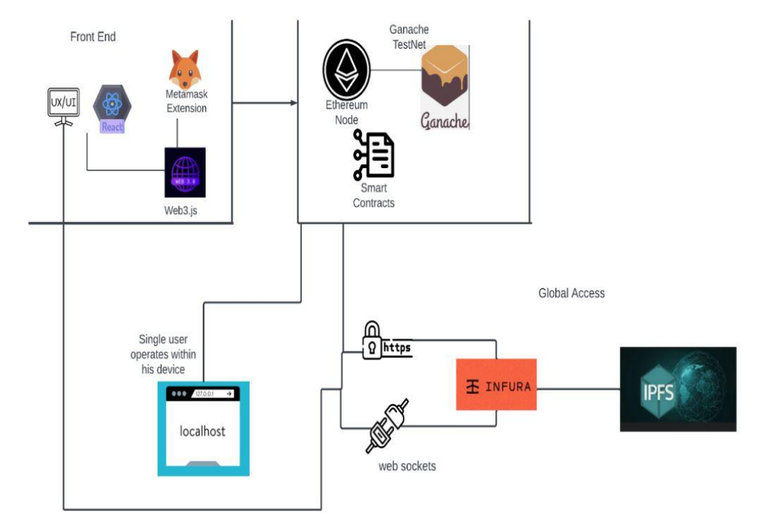

**Figure 3.1: Project Architecture of E-voting system using Ethereum Blockchain.**

**3.2 DESCRIPTION**

**1. Frontend Layer (User Interface Layer)**

This is what the user interacts with directly.

* **UX/UI**: Focuses on providing a smooth and intuitive experience for users.
* **React**: A popular JavaScript framework used to build the front end. It handles dynamic rendering, component-based design, and user interactions.
* **MetaMask Extension**:
  + Acts as a **wallet** and **identity manager**.
  + Allows users to sign transactions and interact with smart contracts.
  + Injects window.ethereum into the browser, enabling connection to the blockchain.
* **Web3.js**:
  + The JavaScript library that acts as a bridge between the **frontend** and the **Ethereum blockchain**.
  + It handles contract interaction, reading from the blockchain, and writing to it via MetaMask.

**2. Blockchain Layer (Ethereum Interaction)**

This is where smart contracts live and blockchain transactions are processed.

* **Ethereum Node**:
  + Represents a full or light client connected to the Ethereum network.
  + Listens for transactions and updates its local blockchain state.
* **Ganache**:
  + A **local Ethereum test network** used during development.
  + Offers fast, free transactions and testing tools.
  + Useful for deploying and testing smart contracts before going live.
* **Smart Contracts**:
  + Written in **Solidity**, they define the business logic (e.g., token transfers, voting mechanisms).
  + Deployed to Ganache during development, or to the Ethereum mainnet/testnet using Infura.

**3. Local Development Environment**

* **Localhost**:
  + Represents the developer or user's personal environment.
  + Useful for rapid testing of frontend interactions and blockchain logic.
  + Connects to Ganache (or other networks) for blockchain simulation.

**4. Global Access Layer**

Once the dApp is ready for wider use, it connects to real blockchain and decentralized services:

* **Infura**:
  + A gateway to access Ethereum and IPFS over the internet.
  + Offers APIs to send/receive blockchain data without running a node.
  + Supports HTTPS and WebSockets:
    - **HTTPS** for RESTful requests (e.g., fetch data, send transactions).
    - **WebSockets** for real-time updates (e.g., contract event listening).
* **IPFS (InterPlanetary File System)**:
  + Used to store files off-chain (e.g., images, metadata) in a decentralized way.
  + IPFS hashes (CIDs) are stored on Ethereum to reference the files.
  + Ensures immutability and availability without relying on central servers.

**Benefits of this Architecture**

* **Decentralization**: No central server for core data or logic.
* **Security**: Transactions must be signed by the user’s wallet.
* **Scalability**: Can move from local Ganache to public Ethereum seamlessly.
* **Persistence**: Files stored on IPFS are immutable and globally accessible.

**3.2 SYSTEM DESIGN :**

**UML diagrams**

The Unified Modeling Language allows the software engineer to express an analysis model using the modeling notation that is governed by a set of syntactic semantic and pragmatic rules.A UML system is represented using five different views that describe the system from distinctly different perspective. Each view is defined by a set of diagram, which is as follows.

* + User Model View
    1. This view represents the system from the user’s perspective.
    2. The analysis representation describes a usage scenario from the end-users perspective.
  + Structural Model view
    1. In this model the data and functionality are arrived from inside the system.
    2. This model view models the static structures.
* Behavioral Model View

It represents the dynamic of behavioral as parts of the system, depicting the interactions of collection between various structural elements described in the user model and structural model view.

* Implementation Model View

In this the structural and behavioral as parts of the system are represented as they are to be built.

* Environmental Model View

In this the structural and behavioral aspects of the environment in which the system is to be implemented are represented.

**3.2.1 Class diagram:-**

The class diagram is the main building block of object oriented modeling. It is used both for general conceptual modeling of the systematic of the application, and for detailed modeling translating the models into programming code. Class diagrams can also be used for data modeling. The classes in a class diagram represent both the main objects, interactions in the application and the classes to be programmed. A class with three sections, in the diagram, classes is represented with boxes which contain three parts:

* The upper part holds the name of the class
* The middle part contains the attributes of the class
* The bottom part gives the methods or operations the class can take or undertake

**Class diagram:**

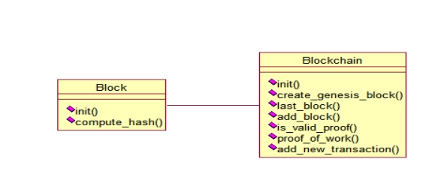

**Figure 3.2.1:Class Diagram**

**3.2.2 Use case diagram:-**

A use case diagram at its simplest is a representation of a user's interaction with the system and depicting the specifications of a use case. A use case diagram can portray the different types of users of a system and the various ways that they interact with the system. This type of diagram is typically used in conjunction with the textual use case and will often be accompanied by other types of diagrams as well.

**Use Case diagram for Admin:**

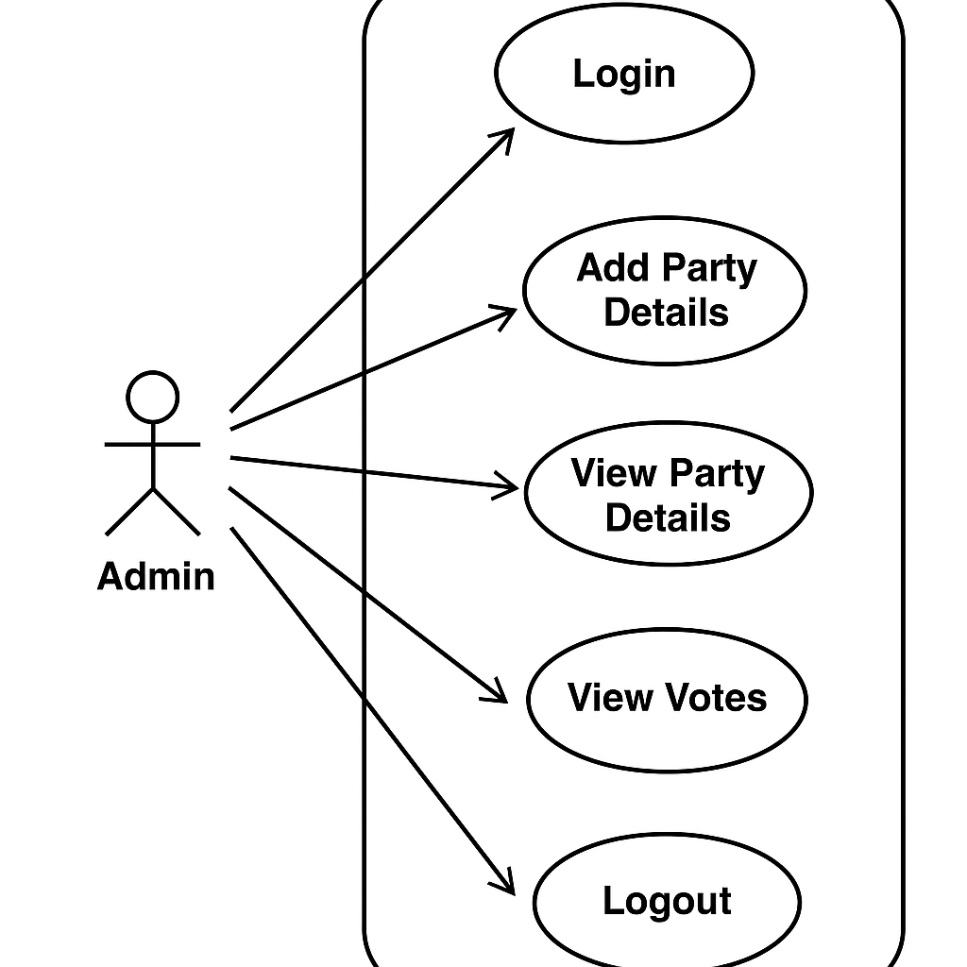

**Figure 3.2.2:use case diagram for admin.**

**Use Case diagram for User:**

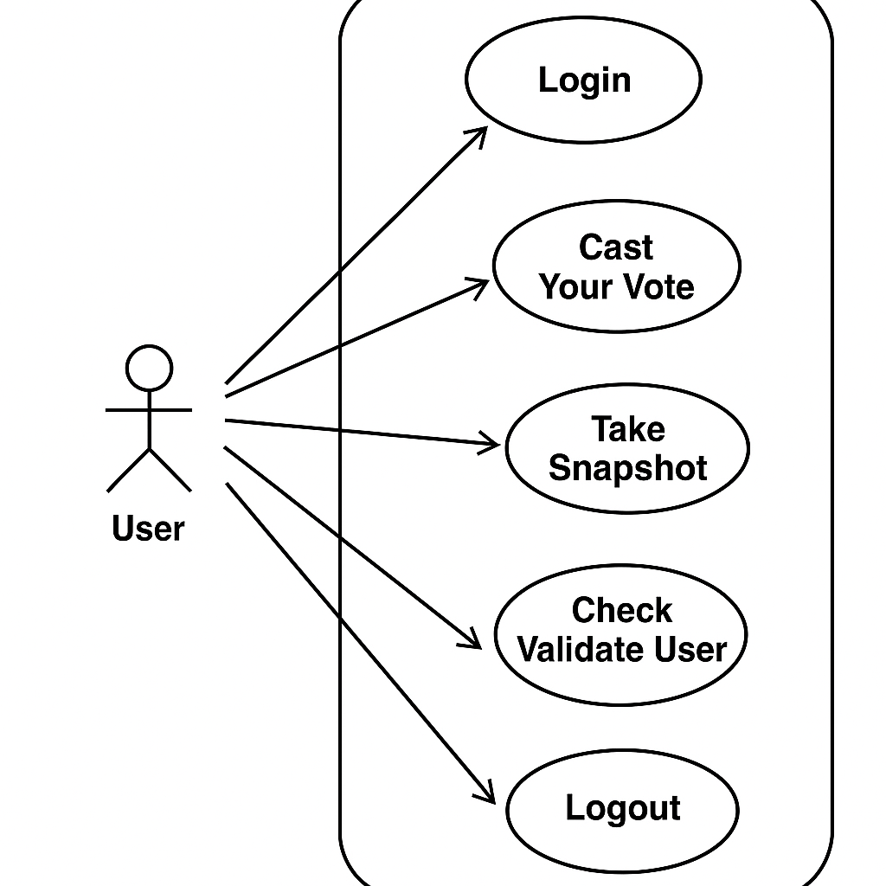

**Figure 3.2.3:use case diagram for user**

**3.2.4 Sequence Diagram:**

A sequence diagram is a kind of interaction diagram that shows how processes operate with one another and in what order. It is a construct of a Message Sequence Chart. A sequence diagram shows object interactions arranged in time sequence.

**Sequence diagram for Admin:**

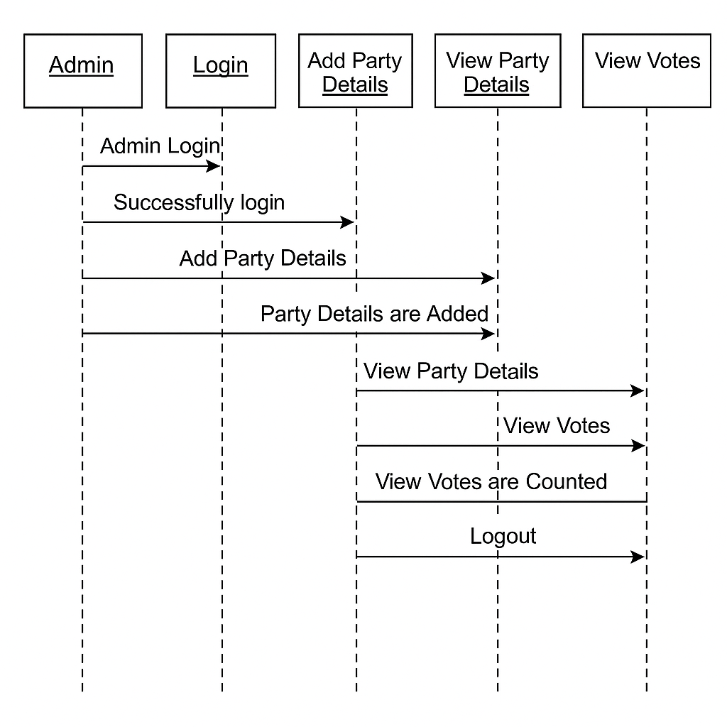

**Figure 3.2.4**:Sequence diagram for Admin.

**Sequence diagram for User:**

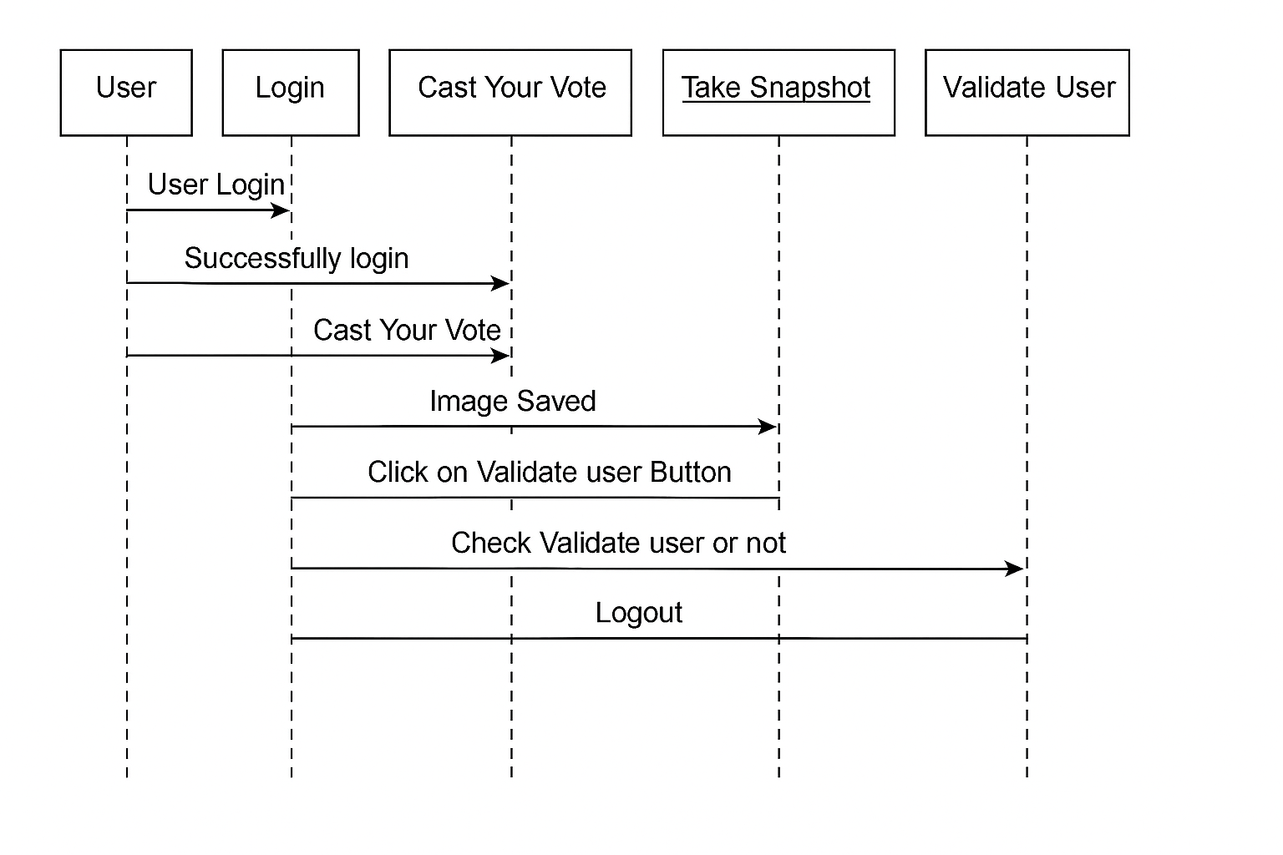

**Figure 3.2.5:** Sequence diagram for User.

**3.2.6 Activity diagram:**

Activity diagram is another important diagram in UML to describe dynamic aspects of the system. It is basically a flow chart to represent the flow form one activity to another activity. The activity can be described as an operation of the system. So the control flow is drawn from one operation to another. This flow can be sequential, branched or concurrent.

**Activity diagram for Admin:**

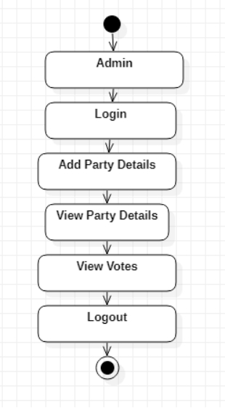

**Figure 3.2.6:Activity diagram for Admin.**

**Activity diagram for user:**

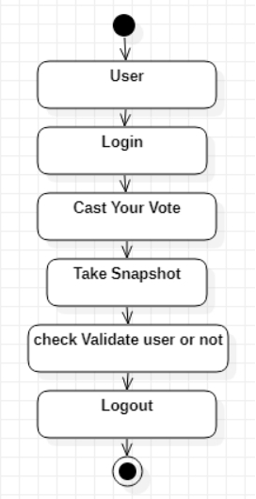

**Figure 3.2.7: Activity diagram for User.**

**3.3 DATA FLOW DIAGRAM**

Data flow diagrams illustrate how data is processed by a system in terms of inputs and outputs. Data flow diagrams can be used to provide a clear representation of any business function. The technique starts with an overall picture of the business and continues by analyzing each of the functional areas of interest. This analysis can be carried out in precisely the level of detail required. The technique exploits a method called top-down expansion to conduct the analysis in a targeted way.

As the name suggests, Data Flow Diagram (DFD) is an illustration that explicates the passage of information in a process. A DFD can be easily drawn using simple symbols. Additionally, complicated processes can be easily automated by creating DFDs using easy-to-use, free downloadable diagramming tools. A DFD is a model for constructing and analyzing information processes. DFD illustrates the flow of information in a process depending upon the inputs and outputs. A DFD can also be referred to as a Process Model. A DFD demonstrates business or technical process with the support of the outside data saved, plus the data flowing from the process to another and the end results.

**Data Flow Diagram for Admin:**

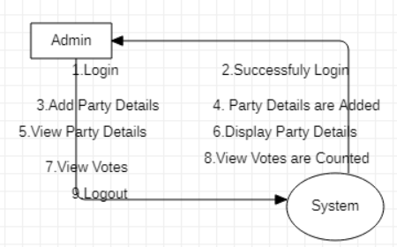

**Figure 3.3.1 : Dataflow Diagram for admin**

**Data Flow Diagram for User:**

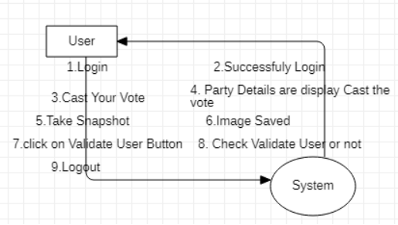

**Figure 3.3.2: Dataflow Diagram for user**

# 4. IMPLEMENTATION

**4.IMPLEMENTATION**

The implementation phase of a project involves executing the planned strategies and tasks. It requires meticulous coordination, resource allocation, and monitoring to ensure that objectives are met efficiently. Effective implementation is crucial for achieving project goals and delivering expected outcomes within the set timeline and budget constraints.

### 1.1 ALGORITHMS USED

#### SHA-256 Hashing (Block Integrity)

This blockchain implementation uses the SHA-256 hashing algorithm from the hashlib library to ensure the integrity of each block. The compute_hash() function serializes a block’s content using json.dumps() and then encodes and hashes it using SHA-256. This creates a unique, fixed-length 64-character hexadecimal string that represents the block. Because SHA-256 is a cryptographic hash function, any minor change in the block's content will completely alter its hash, making it practically impossible to alter the block without detection. This mechanism ensures that blocks are tamper-proof and verifiable.

**Advantages of SHA-256 Hashing (Block Integrity)**

**1.High Security** – Resistant to collisions and reverse engineering.

**2.Deterministic Output** – Same input always gives the same hash.

**3.Tamper Detection** – Even tiny data changes drastically alter the hash.

**4.Efficient Verification** – Fast to compute for validating blocks.

**5.Widely Trusted** – Used in Bitcoin and many security protocols.

**Disadvantages of SHA-256 Hashing (Block Integrity)**

**1.Energy-Intensive Mining** – Requires massive computations in PoW.

**2.Non-Reversible** – Cannot recover original data from the hash.

**3.Quantum Risk** – Could be weakened by future quantum computers.

**4.No Encryption** – Does not provide confidentiality or authentication.

**5.Fixed Output Size** – Always outputs 256 bits, regardless of input size.

**Proof of Work (PoW) Algorithm**

The blockchain includes a simple **Proof of Work** (PoW) algorithm to control how blocks are added to the chain. The proof_of_work() method repeatedly calculates the hash of a block while incrementing a nonce value until it finds a hash that starts with a certain number of zeros—determined by the difficulty level. This process makes it computationally expensive to create a valid block, adding security and preventing spam or malicious block generation. Once a valid hash is found, it is accepted as the proof of work, ensuring that mining requires effort and resources.

**Advantages of Proof of Work (PoW) Algorithm**

**1.Strong Security** – Makes it extremely hard to alter blockchain data.

**2.Decentralization Support** – Allows anyone to participate in mining.

**3.Sybil Attack Resistance** – Prevents malicious actors from gaining control easily.

**4.Proven and Battle-Tested** – Used successfully in Bitcoin and other major blockchains.

**5.Simple to Understand and Implement** – Conceptually straightforward and welldocumented.

**Disadvantages of Proof of Work (PoW) Algorithm**

**1.High Energy Consumption** – Requires massive electricity for mining.

**2.Environmental Impact** – Mining contributes to carbon emissions.

**3.Centralization Risk** – Mining may concentrate in regions with cheap power.

**4.Slow Transaction Processing** – Limited scalability and higher confirmation times.

**5.Hardware Dependency** – Requires expensive and specialized mining equipment.

**Genesis Block Creation**

Every blockchain needs a starting point, which is called the **genesis block**. In this implementation, the create_genesis_block() function creates this first block with index 0, no transactions, the current timestamp, and a previous hash value of "0". Its hash is computed and stored, and the block is appended to the chain. This genesis block acts as the foundation upon which all subsequent blocks are built and linked.

**Block Addition and Validation**

The add_block() method ensures that new blocks are valid before they are appended to the blockchain. It checks that the new block’s previous_hash matches the hash of the last block in the chain and verifies that the given proof (hash) meets the current PoW difficulty requirements. If both checks pass, the block is added to the chain. This validation ensures the blockchain remains consistent and resistant to tampering.

**Transaction Pooling**

New transactions are added to the blockchain via the add_new_transaction() method. These transactions are stored temporarily in an unconfirmed_transactions list. When the mine() function is called, these pending transactions are collected into a new block. Once this block is successfully mined through the proof of work process, it is added to the chain, and the transaction pool is cleared. This mechanism allows for batching multiple transactions into a single block for efficient processing.

**Peer Management**

The system includes basic functionality for managing peers using the addPeer() method. This method allows the addition of peer node details to the peer list, simulating a network of connected nodes in a decentralized environment. While this basic setup does not support full peer-to-peer communication, it lays the groundwork for expanding the system into a distributed blockchain network.

**Data Persistence with Pickle (Serialization)**

To preserve the state of the blockchain between program executions, the save_object() method uses Python’s pickle module to serialize and save blockchain objects to a file. The object is saved in binary format using pickle.dump() with the highest protocol for efficiency. This allows the blockchain to be reloaded later, maintaining continuity and data persistence.

### 4.2 SAMPLE CODE

**Block.py**

from hashlib import sha256

import json

import time

class Block:

def __init__(self, index, transactions, timestamp, previous_hash):

self.index = index

self.transactions = transactions

self.timestamp = timestamp

self.previous_hash = previous_hash

self.nonce = 0

def compute_hash(self):

"""

A function that return the hash of the block contents.

"""

block_string = json.dumps(self.__dict__, sort_keys=True)

return sha256(block_string.encode()).hexdigest()

**Blockchain.py**

from hashlib import sha256

import json

import time

import pickle

from datetime import datetime

import random

import pyaes, pbkdf2, binascii, os, secrets

import base64

class Block:

def __init__(self, index, transactions, timestamp, previous_hash):

self.index = index

self.transactions = transactions

self.timestamp = timestamp

self.previous_hash = previous_hash

self.nonce = 0

def compute_hash(self):

block_string = json.dumps(self.__dict__, sort_keys=True)

return sha256(block_string.encode()).hexdigest()

class Blockchain:

# difficulty of our PoW algorithm

difficulty = 2 #using difficulty 2 computation

def __init__(self):

self.unconfirmed_transactions = []

self.chain = []

self.create_genesis_block()

self.peer = []

self.translist = []

def create_genesis_block(self): #create genesis block

genesis_block = Block(0, [], time.time(), "0")

genesis_block.hash = genesis_block.compute_hash()

self.chain.append(genesis_block)

@property

def last_block(self):

return self.chain[-1]

def add_block(self, block, proof): #adding data to block by computing new and previous hashes

previous_hash = self.last_block.hash

if previous_hash != block.previous_hash:

return False

if not self.is_valid_proof(block, proof):

return False

block.hash = proof

#print("main "+str(block.hash))

self.chain.append(block)

return True

def is_valid_proof(self, block, block_hash): #proof of work

return (block_hash.startswith('0' * Blockchain.difficulty) and block_hash == block.compute_hash())

def proof_of_work(self, block): #proof of work

block.nonce = 0

computed_hash = block.compute_hash()

while not computed_hash.startswith('0' * Blockchain.difficulty):

block.nonce += 1

computed_hash = block.compute_hash()

return computed_hash

def add_new_transaction(self, transaction):

self.unconfirmed_transactions.append(transaction)

def addPeer(self, peer_details):

self.peer.append(peer_details)

def addTransaction(self,trans_details): #add transaction

self.translist.append(trans_details)

def mine(self):#mine transaction

if not self.unconfirmed_transactions:

return False

last_block = self.last_block

new_block = Block(index=last_block.index + 1,

transactions=self.unconfirmed_transactions,

timestamp=time.time(),

previous_hash=last_block.hash)

proof = self.proof_of_work(new_block)

self.add_block(new_block, proof)

self.unconfirmed_transactions = []

return new_block.index

def save_object(self,obj, filename):

with open(filename, 'wb') as output:

pickle.dump(obj, output, pickle.HIGHEST_PROTOCOL

# 

# 

# 

# 5. RESULTS & DISCUSSION

**5.RESULTS & DISCUSSION**

The following screenshots showcase the results of our project, highlighting key features and functionalities. These visual representations provide a clear overview of how the system performs under various conditions, demonstrating its effectiveness and user interface. The screenshots serve as a visual aid to support the project's technical and operational achievements.

#### 5.1 GUI/Main Interface :

In below screen, click on ‘Admin Login’

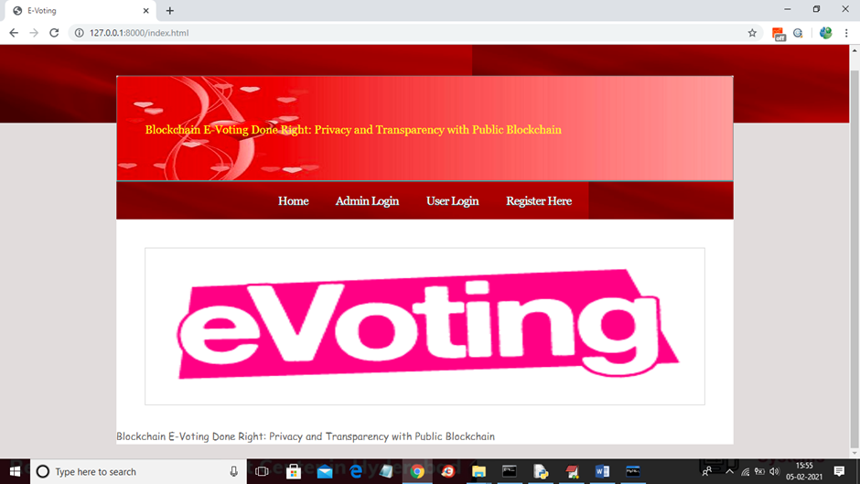

**Figure 5.1 : GUI/Main Interface of E-Voting system**

#### 5.2 Admin Login:

In below screen, login as admin by giving username as ‘admin’ and password as ‘admin’ and then click Login button.

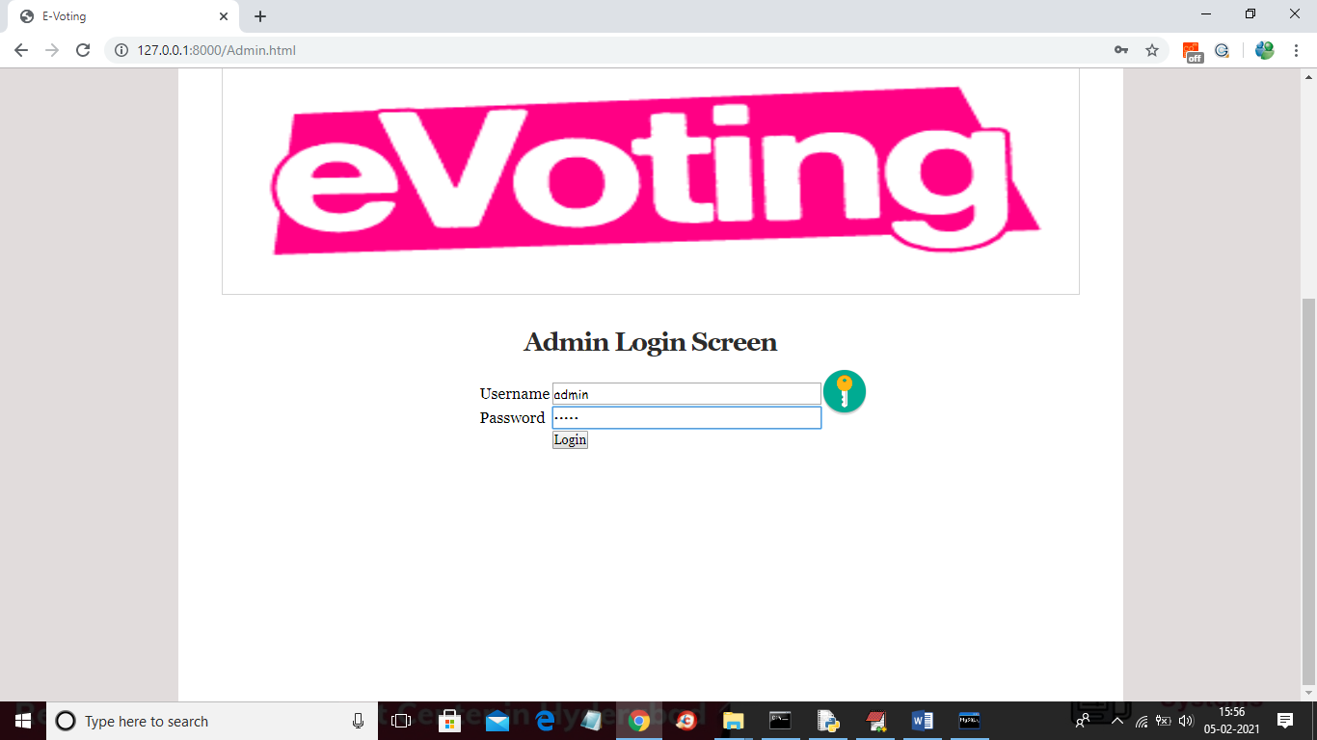

**Figure 5.2 : Admin Login screen of E-voting system using Ethereum blockchain.**

#### 5.3 Add Party Details :



**Figure 5.3 : Admin can click on ‘****Add Party Details’ link to add party details**

#### 5.4 Add Party:

In below screen adding party and candidate details and then upload image and click on ‘Open’ button then click on ‘Add Party’ button to add party details

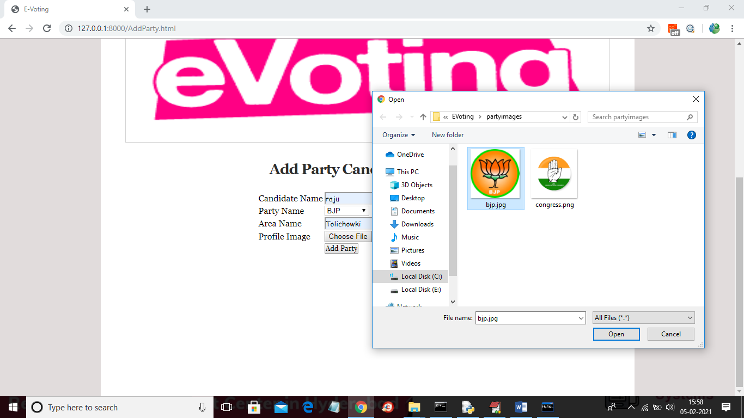

**Figure 5.4 : Adding Party of E-voting system using Ethereum blockchain.**

**5.5 View Party Details :**

In below screen part details added and similarly you can add any number of party members and now click on ‘View Party Details’ link to get below screen



**Figure 5.5 : View party details of E-voting system using Ethereum blockchain**

#### 5.6 Logout as admin :

In below screen displaying add added party details and now click on ‘Logout’ link to logout as admin and then add new user

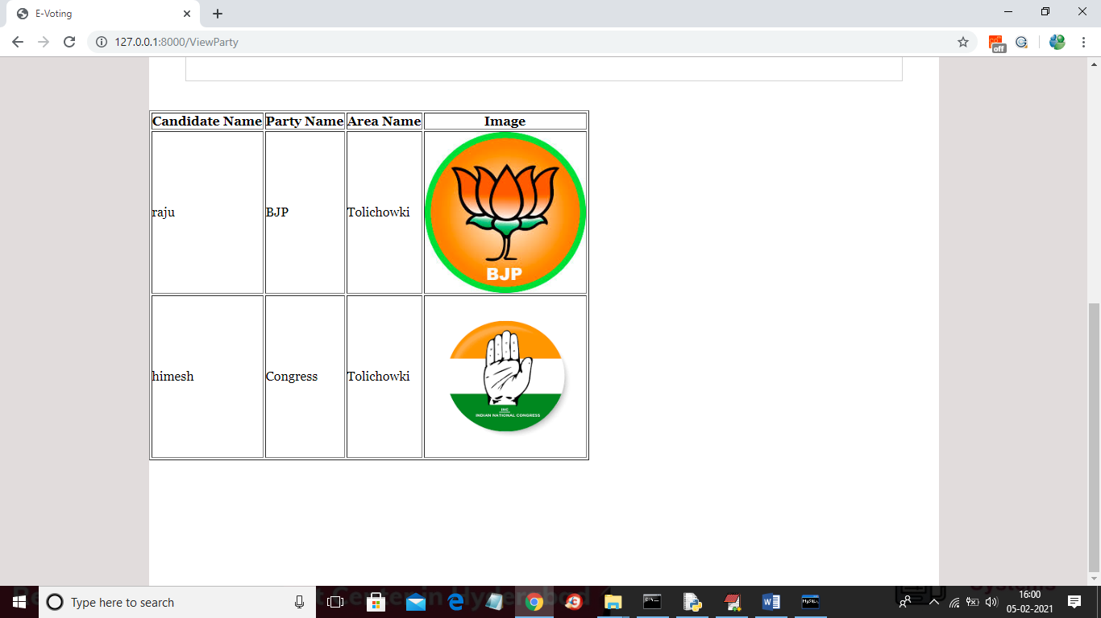

**Figure 5.6 : Displaying add added party details and now click on ‘Logout’ link to logout as admin and then add new user.**

**5.7 :Adding new user**

In below screen adding new user and then selecting his face photo taken from webcam and then click on ‘Register’ button to complete signup process. Here you have given images taken from phone but we need to capture from webcam for dataset as quality of webcam image and phone image vary and then problem comes in prediction.

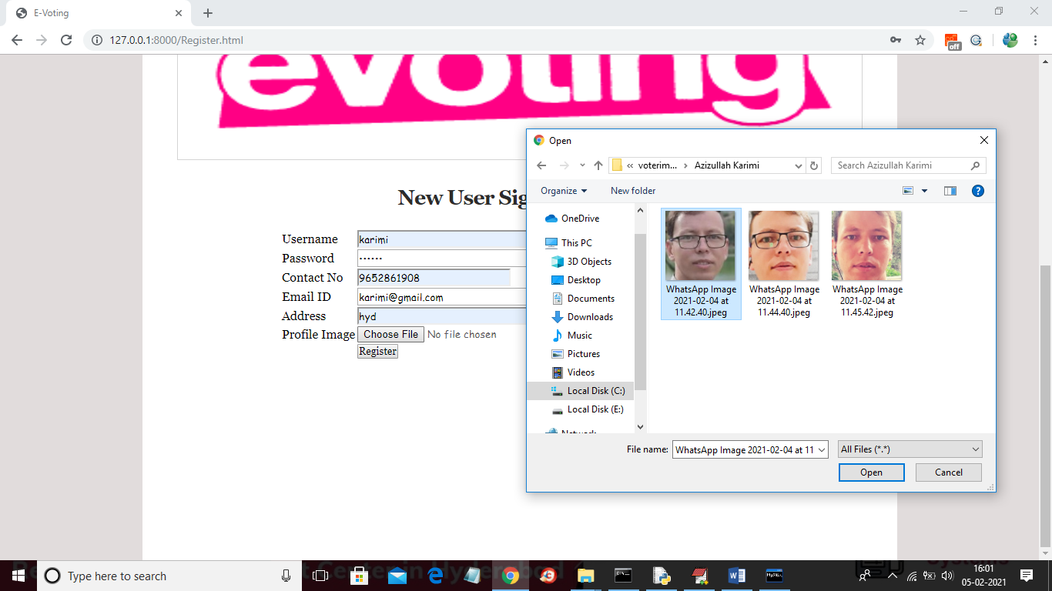

**Figure 5.7: Adding new user and then selecting his face photo taken from webcam.**

**5.8 New user sign up**

In below screen signup process completed and now login as this user to cast vote



**Figure 5.8 : New user signup process completed and now login as this user to cast vote.**

**5.9 User login Screen :**

In above screen application first authenticate user by using his login details and once after successful login .

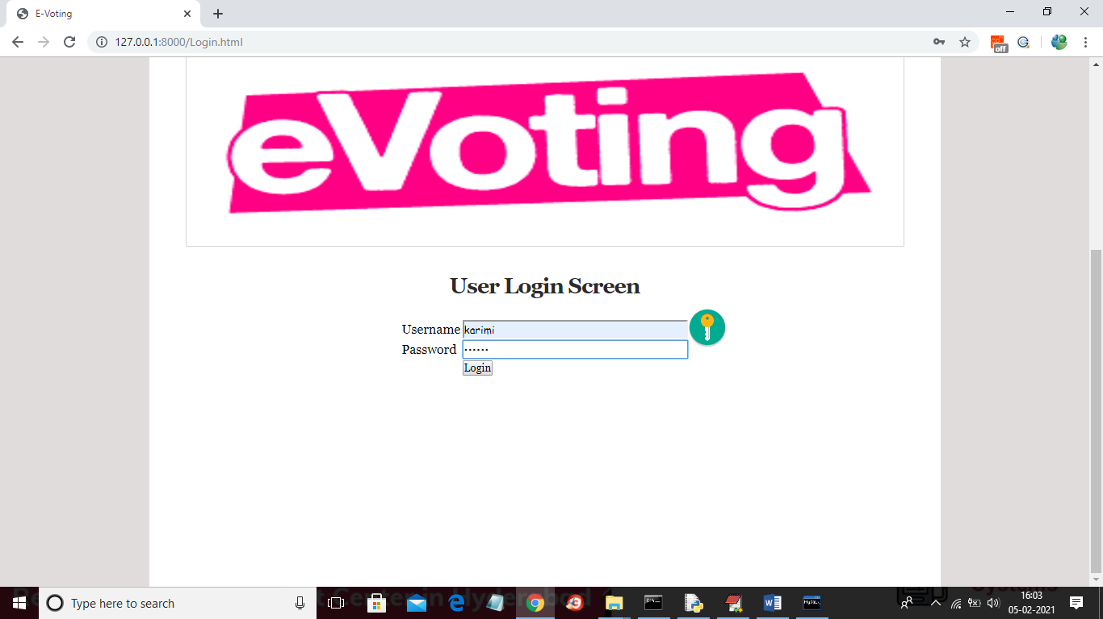

**Figure 5.9: User login screen of E-voting system using Ethereum blockchain.**

**5.10 : Cast Your Vote:**

In below screen user can click on ‘Cast Your Vote’ link to get below webcam screen



**Figure 5.10: Cast user vote of E-voting system using Ethereum blockchain.**

**5.11 : Take Snapshot:**

In below screen webcam is running and then by showing person face we need to click on ‘Take Snapshot’ button to capture his face



**Figure 5.11: webcam is running and then by showing person face we need to click on ‘Take Snapshot**

#### 5.12 : Validate User:

In below screen person faces is capture and now click on ‘Validate User’ button to validate user

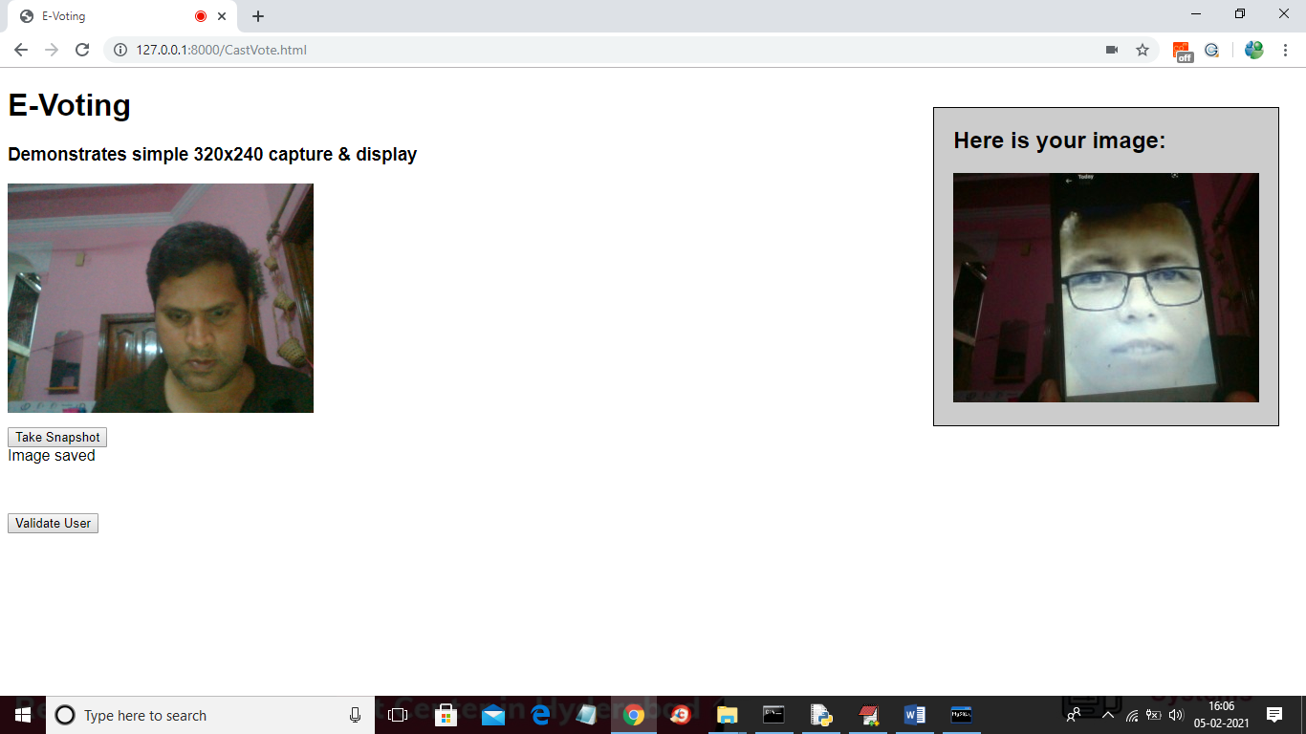

**Figure 5.12 : person faces is capture and ‘Validate User’ button to validate user.**

**5.13:User Validated:**

In below screen in blue colour you can see user is identified as ‘azizullahkarimi’ and then displaying list of candidates and now user can click on ‘Click Here’ option to cast vote .

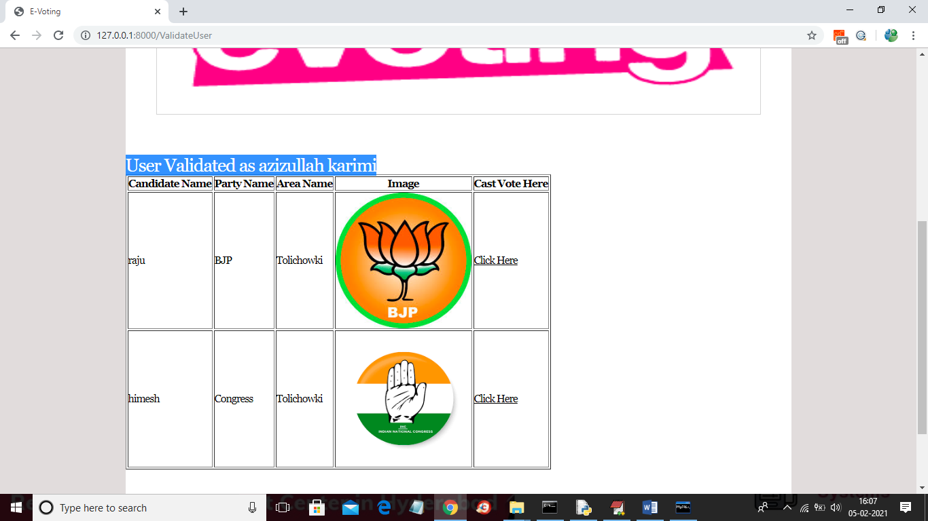

**Figure 5.13: Blue colour you can see user is identified as ‘azizullahkarimi’ and then displaying list of candidates and now user can click on ‘Click Here’ option to cast his vote .**

#### 5.14:Hash code validation:

In below screen as this is the first vote so block will be added to Blockchain with block No as 1 and we can see Blockchain created a chain of blocks with previous and current hash code validation. Now try again with same user to cast vote.

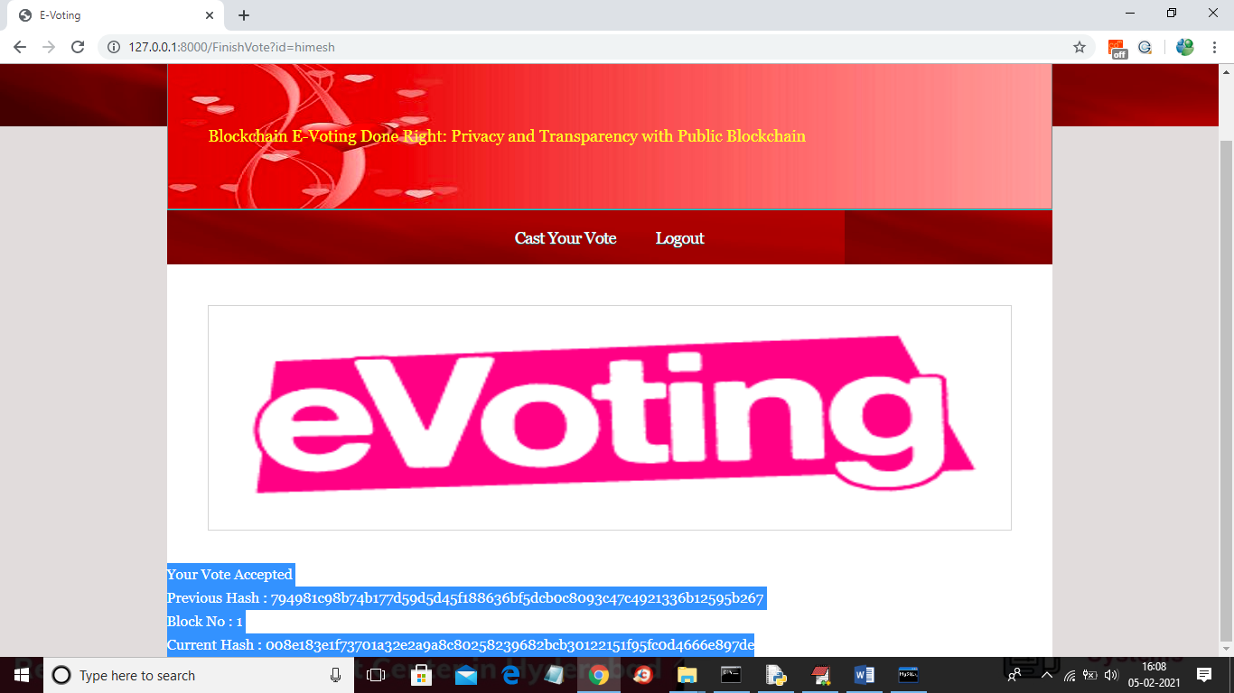

**Figure 5.14 : hash code validation of user.**

**5.15: Checking**

In above screen same user trying again and below is the result

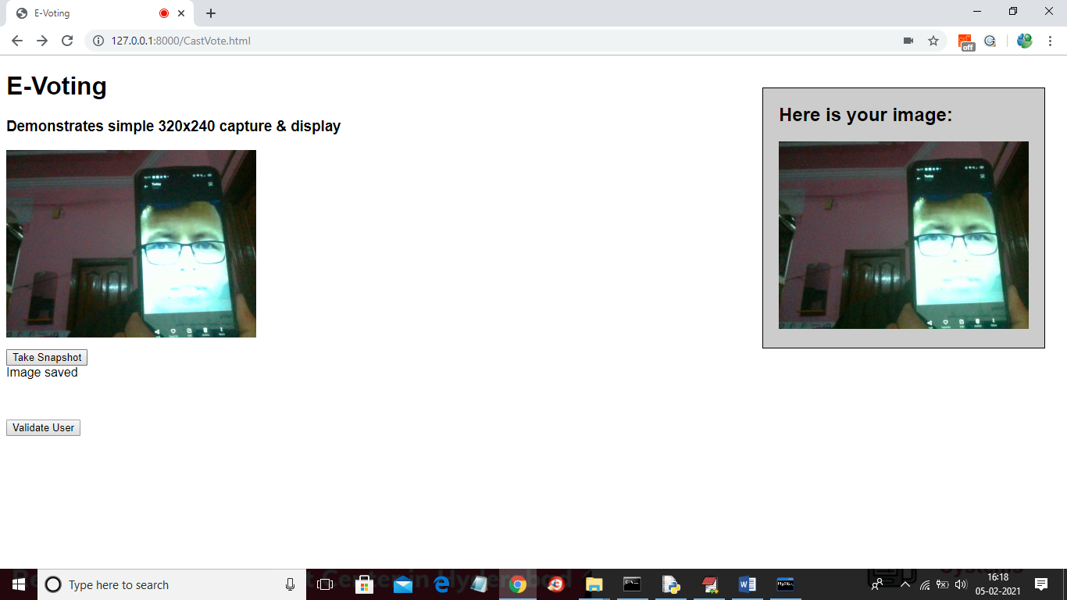

**Figure 5.15.1: Same user trying again to cast there vote.**

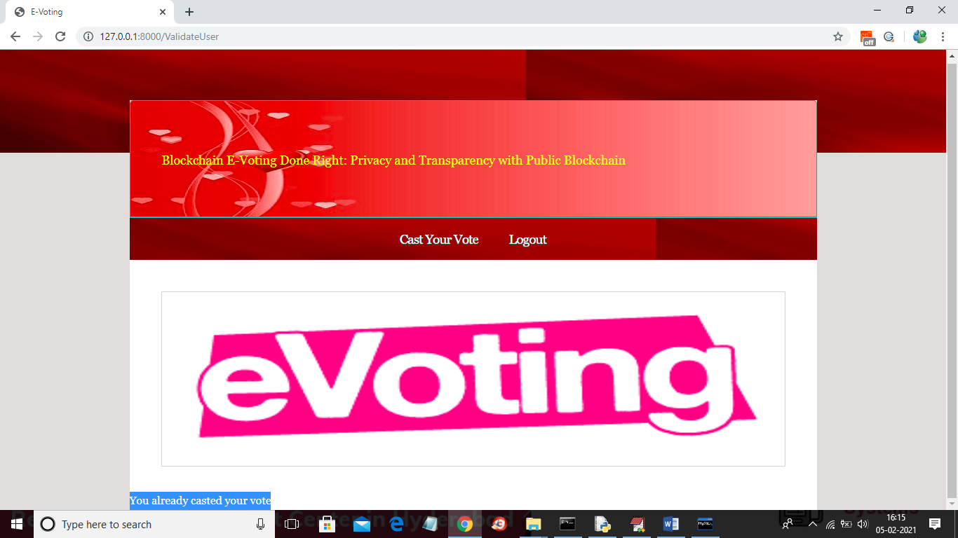

**Figure 5.15.2 : if same user try again then will get message as ‘You already casted you vote’ and now logout and login as ‘admin’ to get vote count.**

**5.16:Admin login :**

In below screen login as admin and after login will get below screen

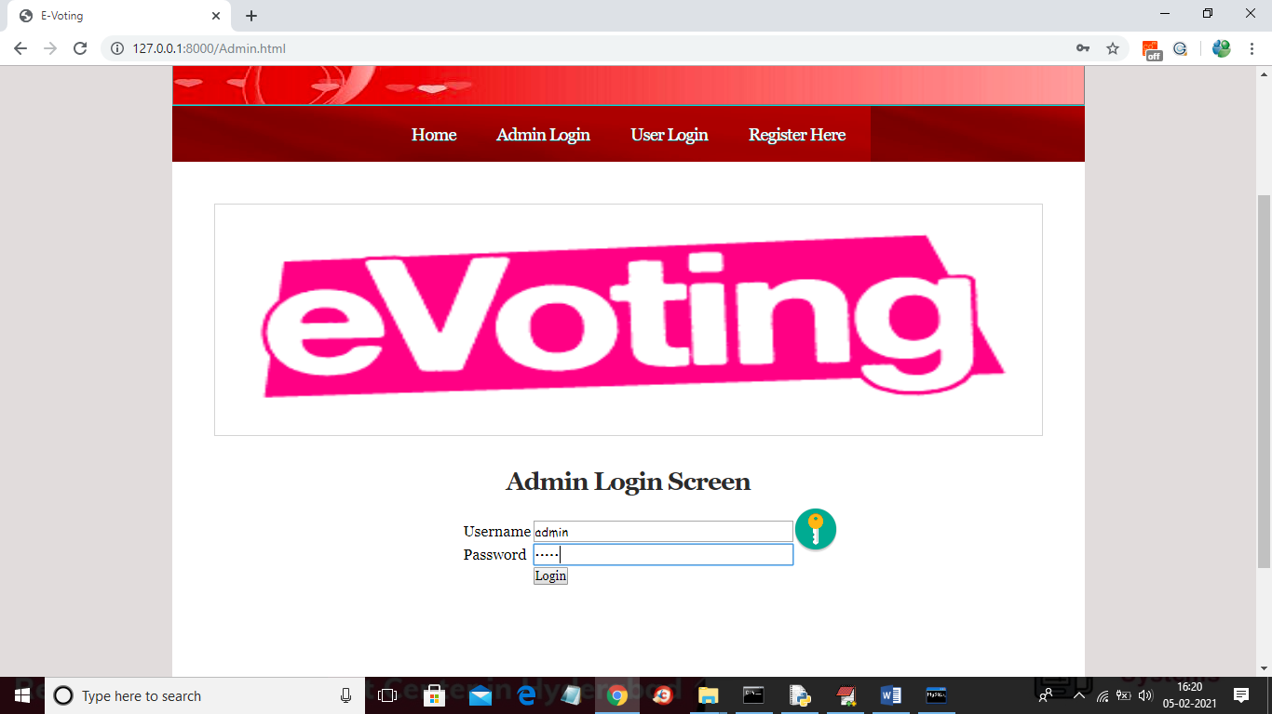

**Figure 5.16: Admin login screen of E-voting system using Ethereum blockchain.**

#### 5.17 View Votes :

In below screen admin can click on ‘View Votes’ link to get below screen



**Figure 5.17 :Admin can viewing the votes**

**5.18 votes count:**

In below screen admin can view all vote counts.

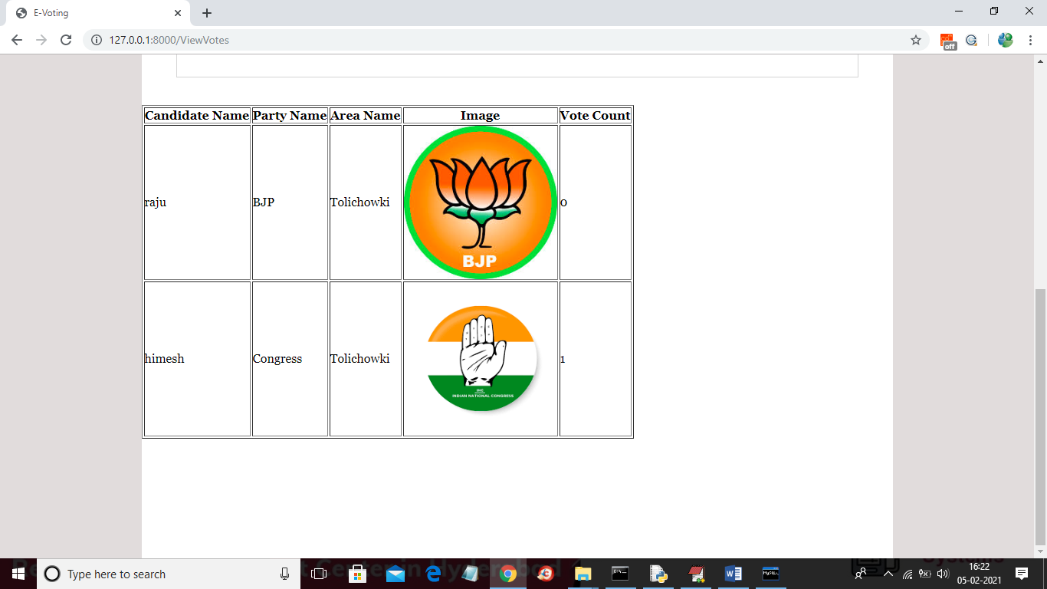

**Figure 5.18: vote counting**

**6. VALIDATION**

## 6.VALIDATION

### The validation of this project primarily relies on extensive testing and well-defined test cases to ensure the accuracy, integrity, and security of the Ethereum-based e-voting system. The testing process spans several phases, including smart contract verification, transaction integrity testing, UI/UX validation, and end-to-end simulation. By implementing a structured validation approach, we ensure the system delivers trustworthy, tamper-proof, and transparent voting functionality, while minimizing vulnerabilities and usability issues

### 

### 6.1 INTRODUCTION

First, the smart contracts responsible for the core voting logic are rigorously tested using local blockchain environments such as Ganache, employing a variety of edge case scenarios to validate correct behavior. These include scenarios like duplicate voting attempts, unauthorized access, and invalid input handling. Unit tests are written and executed to evaluate the correctness and efficiency of functions such as voter registration, vote casting, and result tallying.

To further ensure robustness, K-fold testing and functional integration tests are carried out across multiple simulated user environments. This guarantees that the smart contracts and frontend components interact correctly across different devices and browsers, reinforcing system stability and scalability.

The performance of the system is measured using key metrics such as transaction confirmation time, gas efficiency, and system throughput under load. These metrics are critical in assessing the real-world viability of the e-voting platform. Moreover, event logging, error handling, and user feedback mechanisms are tested to ensure smooth and clear user interactions throughout the voting process.

Additionally, the proposed system—built using React, Web3.js, MetaMask, and Ethereum smart contracts—is benchmarked against other blockchain voting approaches, highlighting its improved transparency, user-friendliness, and resistance to manipulation.

Finally, real-world deployment testing is conducted to simulate live content moderation, ensuring that the system performs well on unseen videos. Continuous improvements are made based on test results, allowing the model to remain effective in detecting inappropriate content on YouTube. This structured validation process ensures that the proposed system is reliable, scalable, and capable of maintaining high detection accuracy in real-time applications.

**6.2 TEST CASES**

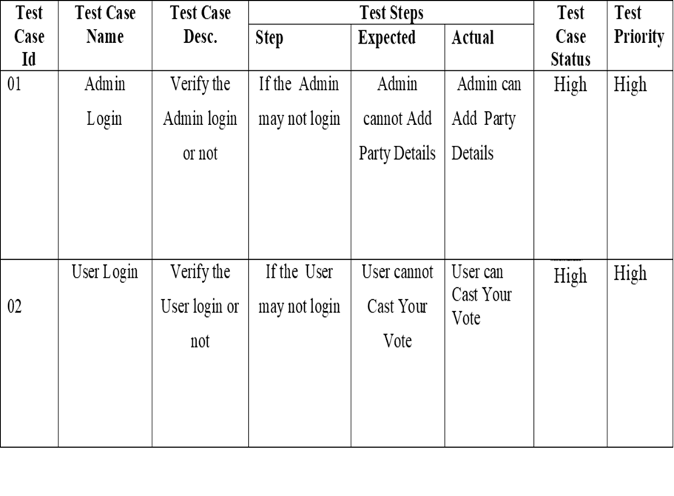

**TABLE 6.3.1 Test cases**

# 7. CONCLUSION &

# FUTURE ASPECTS

**7 CONCLUSION & FUTURE ASPECTS**

In conclusion, the project has successfully achieved its objectives, showcasing significant progress and outcomes. The implementation and execution phases were meticulously planned and executed, leading to substantial improvements and insights. Looking ahead, the future aspects of the project hold immense potential. Future developments will focus on expanding the scope, integrating new technologies, and enhancing sustainability. These advancements will not only strengthen the existing framework but also open new avenues for growth and innovation, ensuring the project remains relevant and impactful in the long term. This strategic approach will drive continuous improvement and success.

### 7.1 PROJECT CONCLUSION

The implementation of an e-voting system using the Ethereum blockchain demonstrates a promising advancement in the modernization of electoral processes. Traditional voting systems often face issues related to transparency, voter fraud, and administrative inefficiencies. Blockchain technology, with its decentralized and immutable nature, provides a solution that can significantly enhance the integrity and trustworthiness of elections. Ethereum, in particular, with its support for smart contracts, enables the automation of vote recording, verification, and counting, reducing human intervention and the potential for manipulation.

One of the core strengths of using Ethereum in e-voting lies in its ability to provide transparency without compromising security. Every vote cast on the blockchain is cryptographically recorded and cannot be altered, ensuring that all votes are accounted for exactly as cast. At the same time, privacy-preserving techniques such as zero-knowledge proofs or anonymized voter IDs can be integrated to ensure voter anonymity, a critical requirement for any voting system.

Furthermore, the accessibility and global reach of blockchain networks offer new opportunities for remote and disenfranchised populations to participate in democratic processes. Voters can cast their ballots from anywhere with an internet

connection, removing geographic and logistical barriers. This can lead to increased voter turnout and greater civic engagement, particularly in countries or regions where physical voting infrastructure is limited or unreliable.

### 7.2 FUTURE ASPECTS

The future of e-voting systems powered by the Ethereum blockchain holds immense potential, particularly as the technology continues to evolve and mature. One of the most promising developments is the ongoing upgrade to Ethereum 2.0, which aims to improve scalability, security, and energy efficiency. With faster transaction processing and reduced gas fees, Ethereum 2.0 can support large-scale elections with millions of voters without compromising performance or cost-effectiveness.

In addition, the integration of advanced cryptographic techniques like zero-knowledge proofs (ZKPs) and homomorphic encryption can enhance voter privacy and enable secure, anonymous vote verification. These technologies allow votes to be validated without revealing the identity of the voter or the content of their vote, ensuring both transparency and confidentiality. The future may also see the development of user-friendly voting interfaces and mobile applications, making blockchain-based voting more accessible to the general public.

Moreover, with increasing interest from governments and international organizations, pilot projects and legal frameworks are likely to emerge that support blockchain voting in official elections. These efforts will be essential in standardizing practices, ensuring compliance with election laws, and building public trust. As digital identity systems and internet accessibility improve globally, blockchain-based e-voting could become a viable and secure option for both national and local elections, enabling more inclusive and efficient democratic participation worldwide.

**8.BIBLIOGRAPHY**

* 1. **BIBLIOGRAPHY**

### 8.1 REFERENCES

[1] N. Kshetri and J. Voas, “Blockchain-Enabled E-Voting,” IEEE Software, vol. 35, pp. 95-99, jul 2018.

[2] M. Pawlak, J. Guziur, and A. Poniszewska-Maranda, “Voting Processwith Blockchain Technology: Auditable Blockchain Voting System,” inLecture Notes on Data Engineering and Communications Technologies, pp. 233-244, Springer, Cham, 2019.

[3] B. Singhal, G. Dhameja, and P. S. Panda, “How Blockchain Works,” in Beginning Blockchain, pp. 31-148, Berkeley, CA: Apress, 2018.

[4] Agora, “Agora Whitepaper,” 2018.

[5] R. Perper, “Sierra Leone is the first country to use blockchain duringan election - Business Insider,” 2018.

[6] S. Nakamoto, “Bitcoin: A Peer-to-Peer Electronic Cash System,” tech.rep., 2008.

[7] G. Wood et al., “Ethereum: A secure decentralized generalized transaction ledger,” Ethereum project yellow paper, vol. 151, pp. 1-32, 2014.

[8] S. Landers, “Netvote: A Decentralized Voting Platform – Netvote Project Medium,” 2018.

[9] P. McCorry, S. F. Shahandashti, and F. Hao, “A Smart Contract for Boardroom Voting with Maximum Voter Privacy,” in Lecture Notes in Computer Science, ch. FCDS, pp. 357-375, Springer, Cham, 2017.

[10] Z. Brakerski and V. Vaikuntanathan, “Efficient Fully Homomorphic Encryption from (Standard) LWE,”SIAM Journal on Computing, vol. 43,pp. 831-871, jan 2014.

[11] O. Goldreich and Y. Oren, “Definitions and properties of zero knowledge proof systems,” Journal of Cryptology, vol. 7, no. 1, pp. 1-32, 1994.

**8.2 GITHUB LINK:**

https://github.com/Bharugoud1024/E-voting-system-using-Ethereum-Blockchain.git